PART ONE
Answer all questions is extremely thorough and supported with substantial relevant details.
The purpose of this assignment is to explain core concepts related to the U.S. financial system
While APA style is not required for the body of this assignment, solid academic writing is expected, and documentation of sources should be presented using APA formatting guidelines

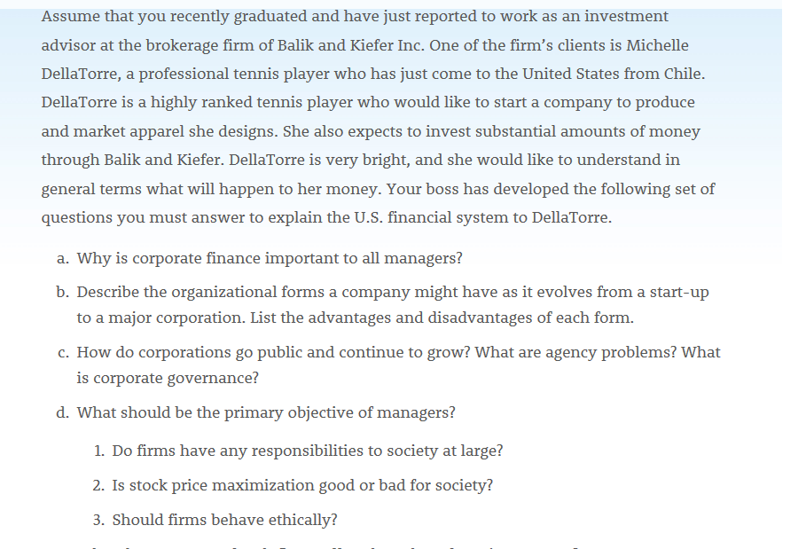

PART TWO
The purpose of this assignment is to explain core concepts related to corporate valuation and governance and to identify strategies for conducting business with personal and professional integrity.
While APA style is not required for the body of this assignment, solid academic writing is expected, and documentation of sources should be presented using APA formatting guidelines
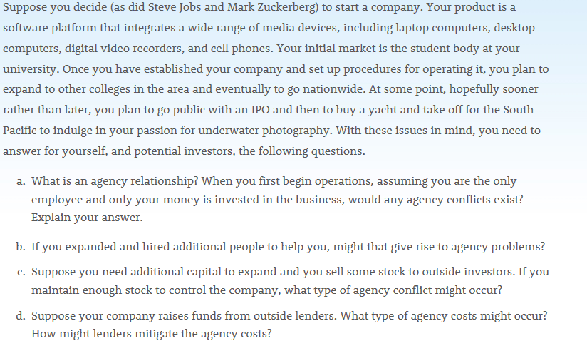
Using the information, write a 250-500 word letter of intent discussing specific strategies for how you will conduct your start-up business with personal and professional integrity

